By the look of the file and the program you can see this is written in python. You can go ahead and run your test cases and run the program. So far, this program is to be run in the same directory for it to work efficiently because it is not written to open files from different directories but only from the same directory. Whatever file is created has to be access from the same directory.

SUCCESS CASES:

ERROR CASES:

AddUser

Authenticate

SetDomain

DomainInfo



SetType

TypeInfo

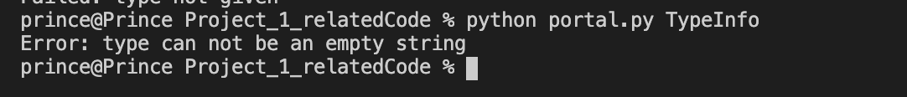

AddAccess

CanAccess

